Los Angeles Parking Citations: Final Project Report

1. **Application Description**

Our application is based on the issuing of parking citations in the city of Los Angeles. It is a console-based database application with MongoDB running in a cluster on AWS. Users will be able to interact with the database by inserting, updating, and deleting documents through the console regarding information about parking citations. The Los Angeles Department of Transportation may use this application to gather specific data about locality where parking citations are issued and which rules are being violated in order to further enforce traffic laws.

We are using NoSQL deployment versus a traditional relational database management system (RDBMS) because the data is unstructured. Our chosen data set, described later in the report, does not have a fixed schema--the fields may vary between documents, as some fields may exist in some and be non-existent in others. Traditional RDBMSs would store all of the non-existent field values as NULL, resulting in a table that is very wide that wastes space. MongoDB gives us more flexibility by allowing us to store this varying data such that each document can have different field-value pairs.

1. **Project Successes**

One beneficial choice was choosing Pymongo and Python as a programing language, as Python is easy to get running, has a very robust package manager, many libraries to choose from, and was very easy to use and implement for our application.

Our team was also very proactive about getting the project done and was a pleasure to work with despite the end of the semester and other projects being due.

1. **Unexpected Events**

While Python is an easy language to pick up, some of our team never used it and needed to get familiar with the environment, best practices, and syntax through tutorials and Google searches.

Wrangling the data set into JSON format for bulk insert into MongoDB proved to be challenging given the size of the dataset. Our team looked for the most efficient way to do so while tackling different avenue. In the end, splitting the data into smaller sections and wrangling it one by one was the easiest method.

1. **Lesson Learned**

Python is a great language and has a great ecosystem, but setting up that environment can sometimes prove to be challenging due to incompatibility with different Python versions, default Python version installed on our operating systems, and different plugins. Additionally, due to the above portability of a script or app, it can be challenging to bundle together as a package. Nothing to be done for that except maybe switching languages, however, they all have their pros and cons.

1. **Dataset**

URL: <https://www.kaggle.com/cityofLA/los-angeles-parking-citations#parking-citations.csv>

We are using a public data set for Los Angeles Parking Citations hosted by the city of Los Angeles from Kaggle. This data set contains information about parking citations in Los Angeles, including information about the ticket number, time and date of its issuing, car information (excluding license plate number), violation description and fine, and location in latitude and longitude of the citation issuing.

Data Wrangling: The data set is given in a .csv file which is 1.21 GB. To wrangle this data for importing and querying in MongoDB, we first had to convert the .csv file to .json format. We were able to accomplish this by reading the .csv file in a Python Pandas DataFrame, dropping the null values for each row, converting each row to JSON, and uploading the .json file to AWS.

Data Wrangling Code:  
import pandas as pd  
x=pd.read_csv('/Users/shreya90/Desktop/parking-citations.csv')  
import json   
for index,row in x.iterrows():  
 row=row.dropna()  
 jd= row.to_json()  
 with open('data.json', 'a') as f:  
 f.write(jd+'\n')

1. **Schema Description**

Our database in MongoDB is vparkdb and our collection is vpark. We decided to create an index on the “Ticket number” field to optimize queries involving ticket numbers and finding specific ranges of ticket numbers.

|  |  |  |
| --- | --- | --- |
| Field name | Field type | Field description |
| Ticket number | Integer | A unique identifier for the citation issued |
| Issue Date | String | Date that the ticket was issued |
| Issue time | Integer | Time that the ticket was issued (on a 24-hour clock) |
| Meter Id | String | The ID of meter where the ticket was issued |
| Marked Time | Double | N/A |
| RP State Plate | String | State of the license plate that the ticket was issued to |
| Plate Expiry Date | Timestamp | Date that the license plate expires |
| Make | String | Make of the car that the ticket was issued to (example: TOYT for Toyota, HOND for Honda) |
| Body Style | String | Abbreviation for body style of car ticketed |
| Color | String | Color of the car the ticket was issued to |
| Location | String | Street that the ticket was issued |
| Route | String | Route that the ticket was issued |
| Agency | Integer | Agency ticket was issued by |
| Violation code | String | Code corresponding to specific law violation issued by the city of Los Angeles |
| Violation description | String | Description of the ticket violation |
| Fine amount | Double | Amount in USD of the ticket |
| Latitude | Double | Latitude (in ft.) of location ticket was issued |
| Longitude | Double | Longitude (in ft.) of location ticket was issued |

1. **NoSQL Configuration**

Setting up the cluster in AWS:

**Directory for config-servers:**

sudo mkdir -p /db/skconfig/data (in all three nodes)

**Starting for configservers:**

sudo mongod --port 27022 --dbpath /db/skconfig/data --configsvr --replSet skconfig --bind_ip 172.31.18.13

sudo mongod --port 27022 --dbpath /db/skconfig/data --configsvr --replSet skconfig --bind_ip 172.31.23.91

sudo mongod --port 27022 --dbpath /db/skconfig/data --configsvr --replSet skconfig --bind_ip 172.31.31.175

**Logging to Mongod config server in primary:**

sudo mongo --host 172.31.18.13 --port 27022

**Adding configerver in a replica set (skconfig):**

rs.initiate(

{

_id: "skconfig",

configsvr: true,

members: [

{ _id : 0, host : "172.31.18.13:27022" },

{ _id : 1, host : "172.31.23.91:27022" },

{ _id : 2, host : "172.31.31.175:27022" }

]

}

)

**To connect mongos to all the three configuration servers:**

sudo mongos --configdb skconfig/172.31.18.13:27022,172.31.23.91:27022,172.31.31.175:27022 --port 27021 --bind_ip 172.31.18.13

**Starting Shard servers:**

sudo mongod --port 27023 --dbpath /db/shard0/data --shardsvr --replSet skdata --bind_ip 172.31.18.13

sudo mongod --port 27023 --dbpath /db/shard1/data --shardsvr --replSet skdata --bind_ip 172.31.23.91

sudo mongod --port 27023 --dbpath /db/shard2/data --shardsvr --replSet skdata --bind_ip 172.31.31.175

**Logging to shard server in primary :**

sudo mongo --host 172.31.18.13 --port 27023

**Adding shard server in a replica set:**

rs.initiate(

{

_id: "skdata",

members: [

{ _id : 0, host : "172.31.18.13:27023" },

{ _id : 1, host : "172.31.23.91:27023" },

{ _id : 2, host : "172.31.31.175:27023" }

]

}

)

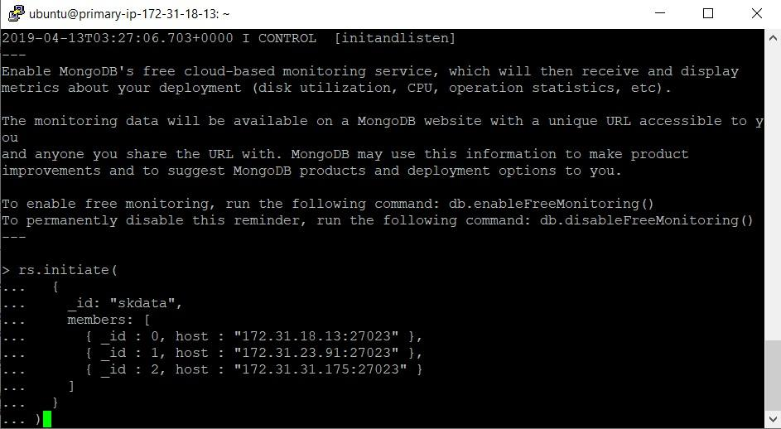

**Logging to Mongos in primary** :

sudo mongo --host 172.31.18.13 --port 27021

**Setting chunksize to 1 mb for better distribution:**

db.settings.save( { _id:"chunksize", value: 1 } )

**Adding Shards in mongos**

sh.addShard( "skdata/172.31.18.13:27023")

sh.addShard( "skdata/172.31.23.91:27023")

sh.addShard( "skdata/172.31.31.175:27023")

**Enabling sharding on database:**

sh.enableSharding("vparkdb")

**Enable shard-key in mongos:**

sh.shardCollection("vparkdb.vpark", { "Violation code" : 1 })

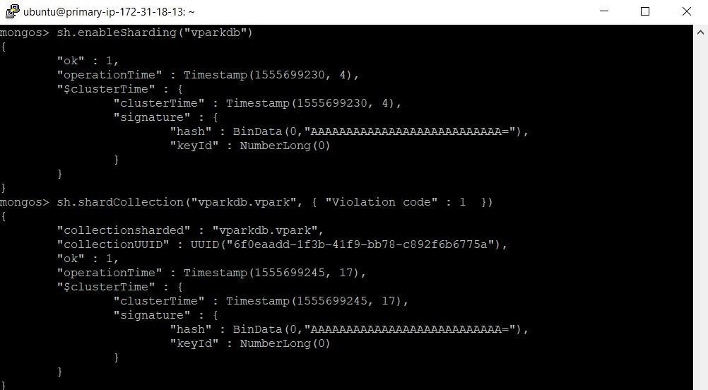

**sh.status() after enabling sharding but before performing mongoimport:**

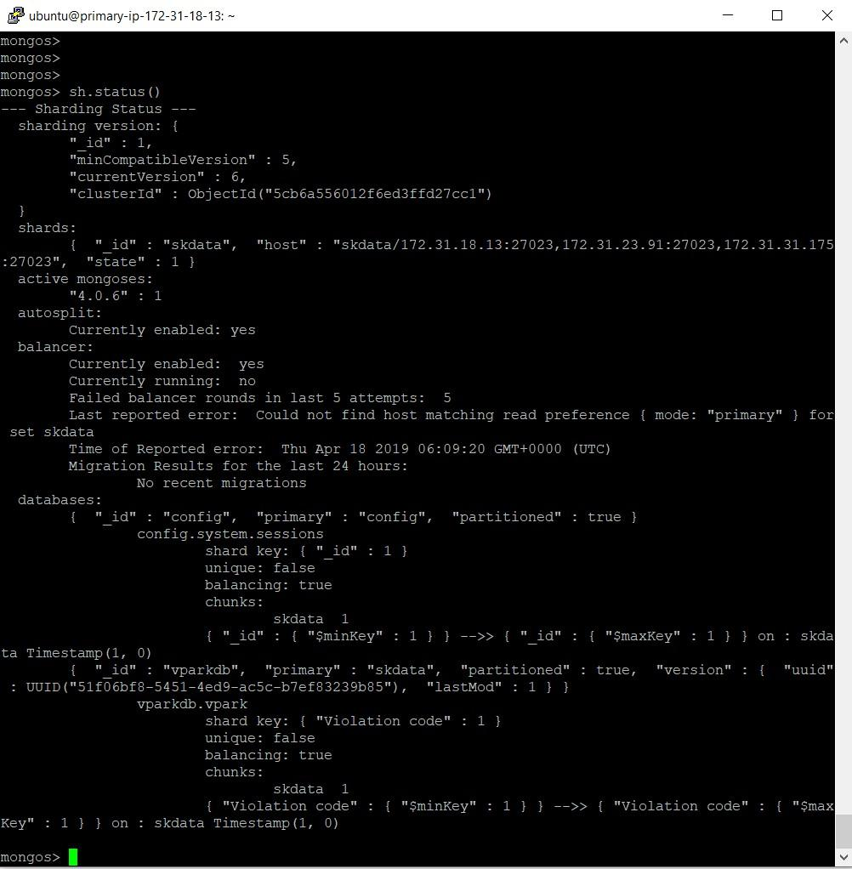

**Uploading JSON data from local machine to AWS instance:**

pscp -i C:\Users\amdut\.ssh\my-key-pair.ppk D:\amdut\Downloads-to\data2\data2.json ubuntu@ec2-52-53-221-67.us-west-1.compute.amazonaws.com:/home/ubuntu/data2.json

pscp -i C:\Users\amdut\.ssh\my-key-pair.ppk D:\amdut\Downloads-to\data2\data3.json ubuntu@ec2-52-53-221-67.us-west-1.compute.amazonaws.com:/home/ubuntu/data3.json

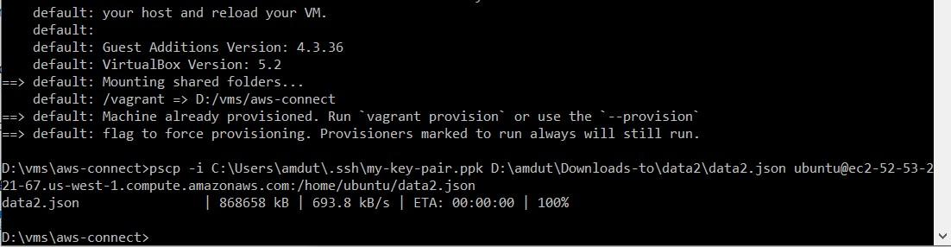

**Mongo Import of files to collection=vpark db=vparkdb:**

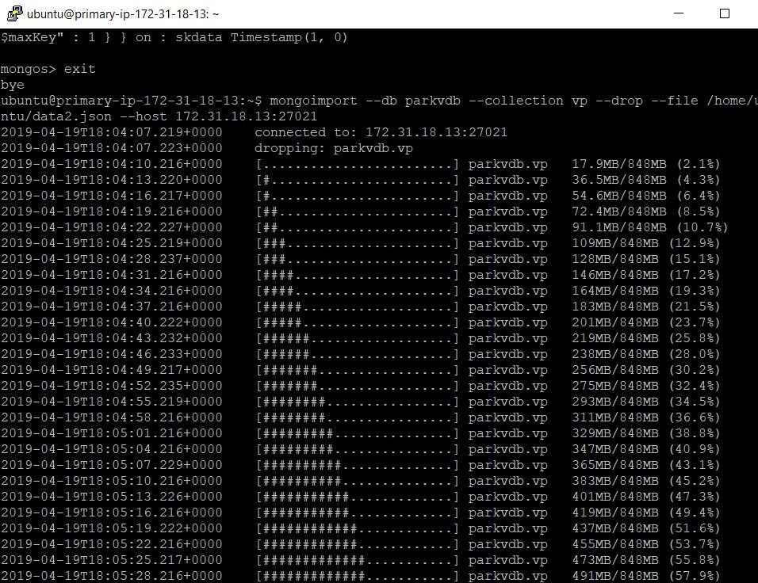

**Displaying the 1.05 GB data in our collection after importing data:**

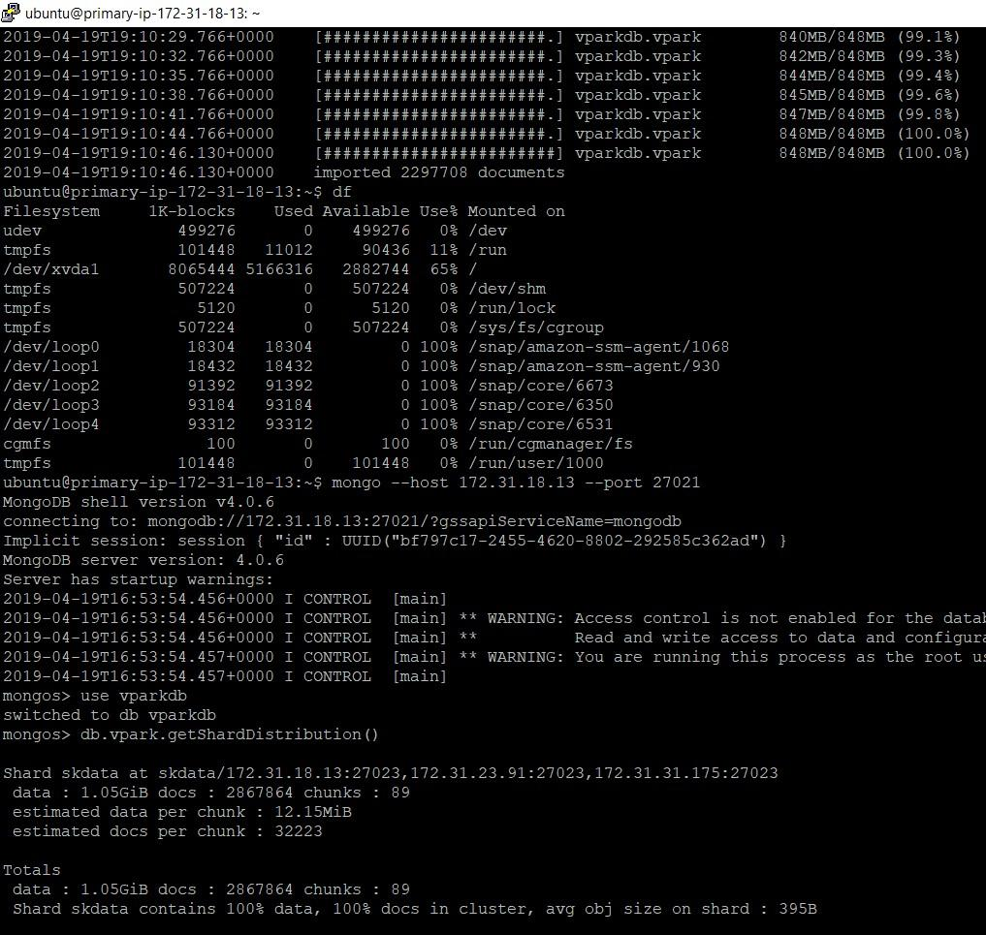

**sh.status(true) for chunk distribution output after importing data:**

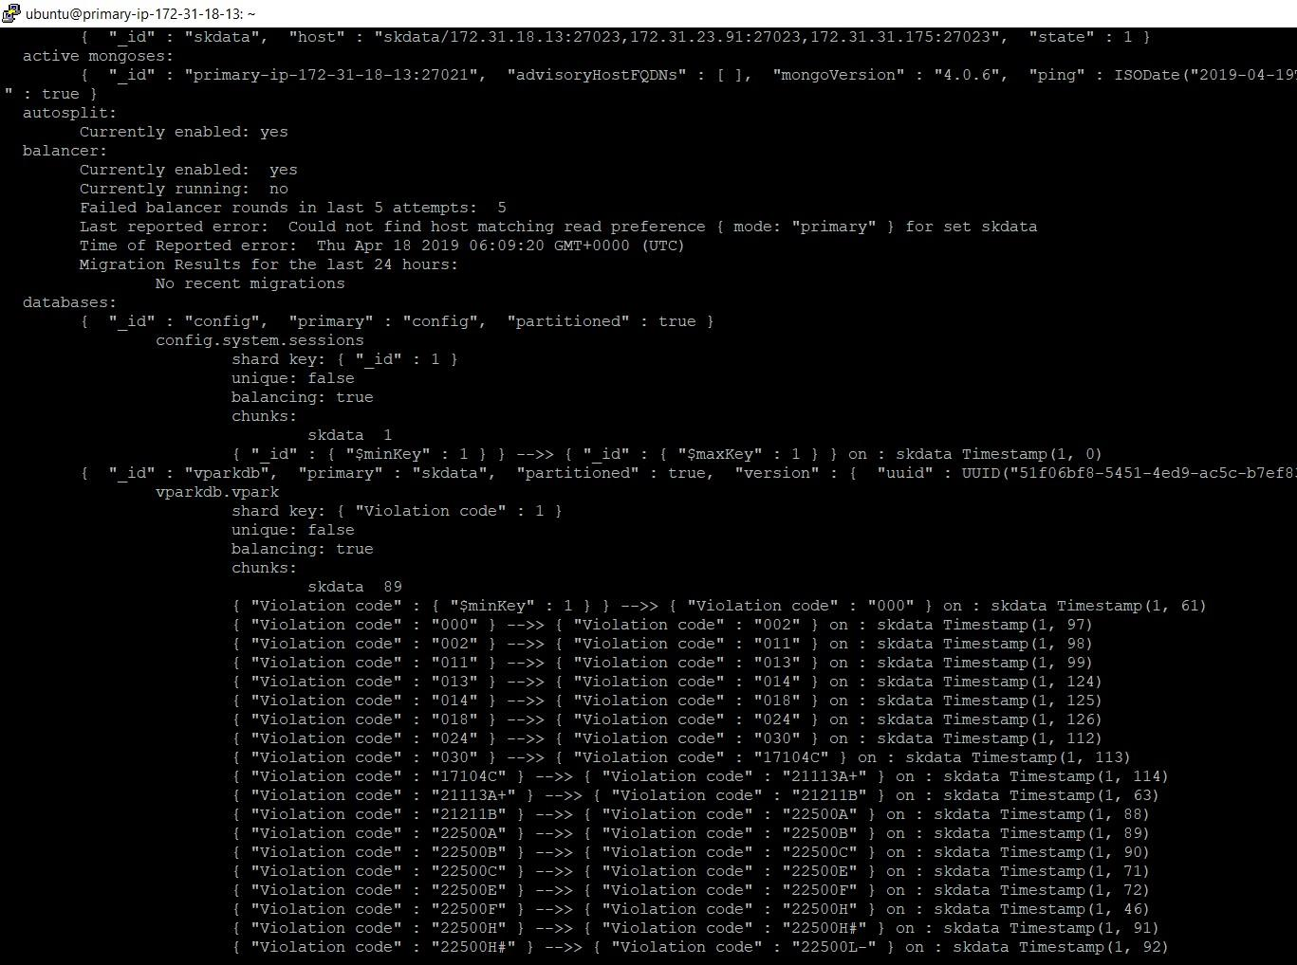

**Security rules for enabling pymongo from local machine to connect to AWS:**

**Local public IP: 71.202.20.112**

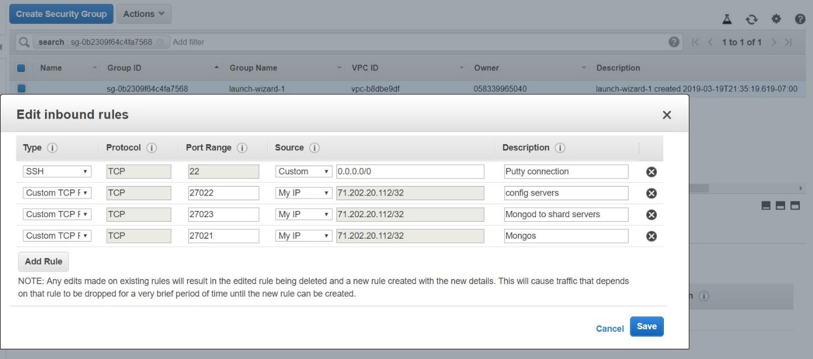

**Example on VM2:**

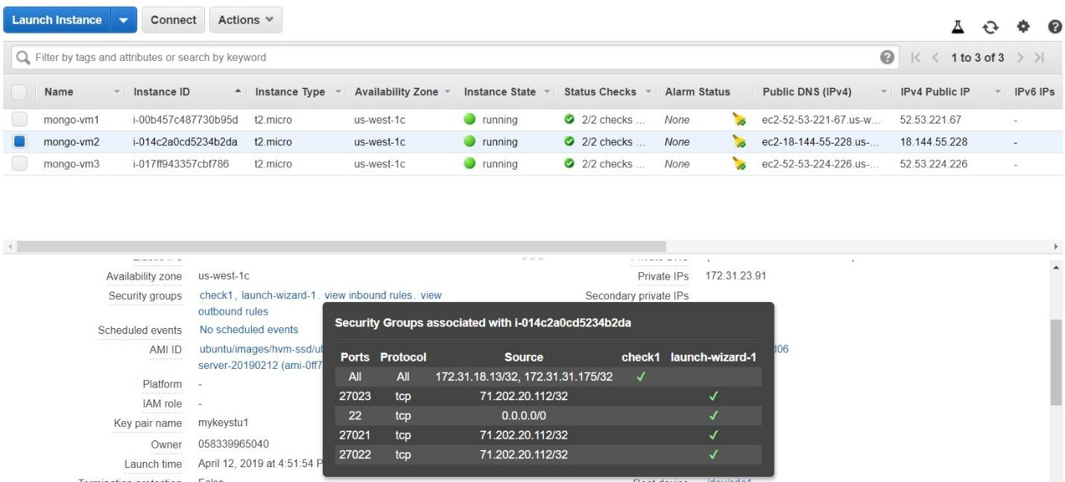

1) Testing an end-to-end connection from application to MongoDB:

**Installing pymongo and testing end-to-end connection from local VM:**

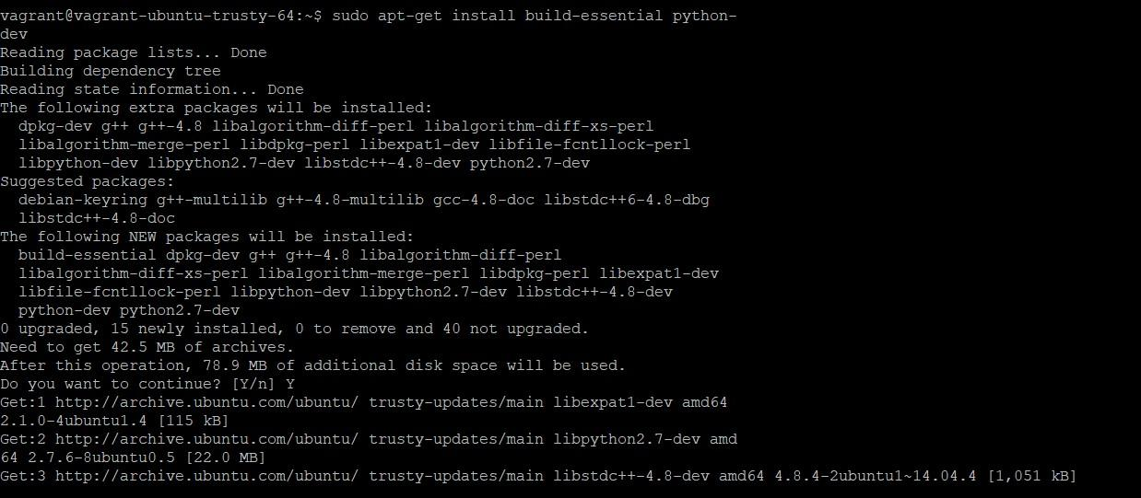

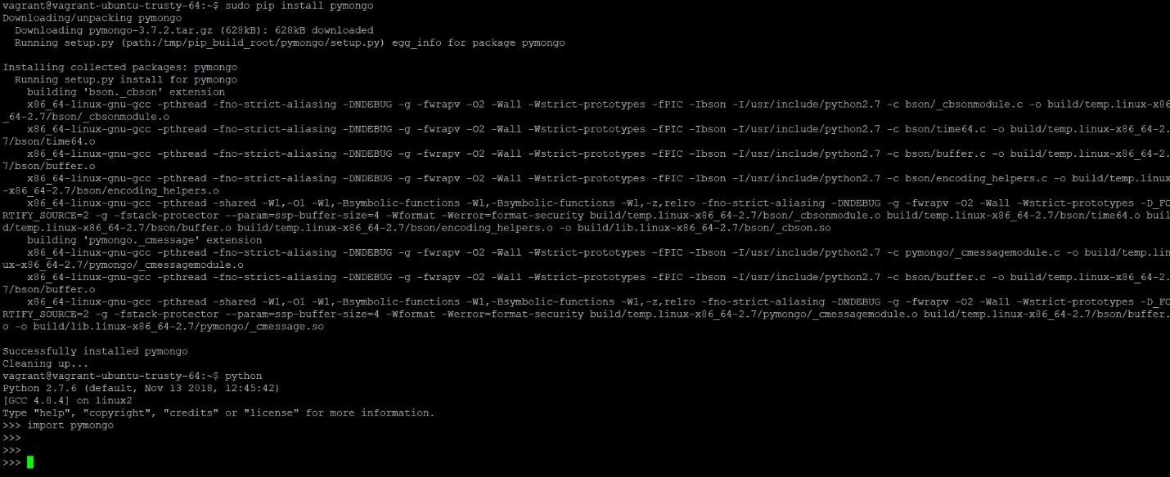

2) Application reads data from the database by executing one of the functions:

**Testing with find_one() from Pymongo client:**

from pymongo import MongoClient

from pprint import pprint

client = MongoClient('mongodb://[ec2-52-53-221-67.us-west-1.compute.amazonaws.com:27023/](http://ec2-52-53-221-67.us-west-1.compute.amazonaws.com:27023/)')

ec2-52-53-221-67.us-west-1.compute.amazonaws.com:27023 ->Public DNS for AWS Mongodb instance (Shard server)primary.

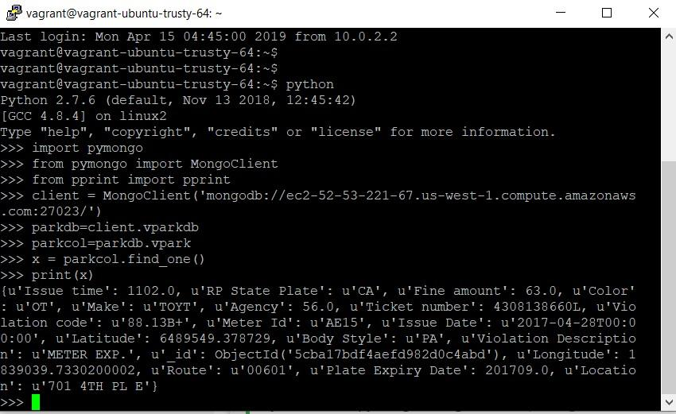

**Checking incoming-pymongo connection on AWS Mongodb instance (Shard server) Primary:**

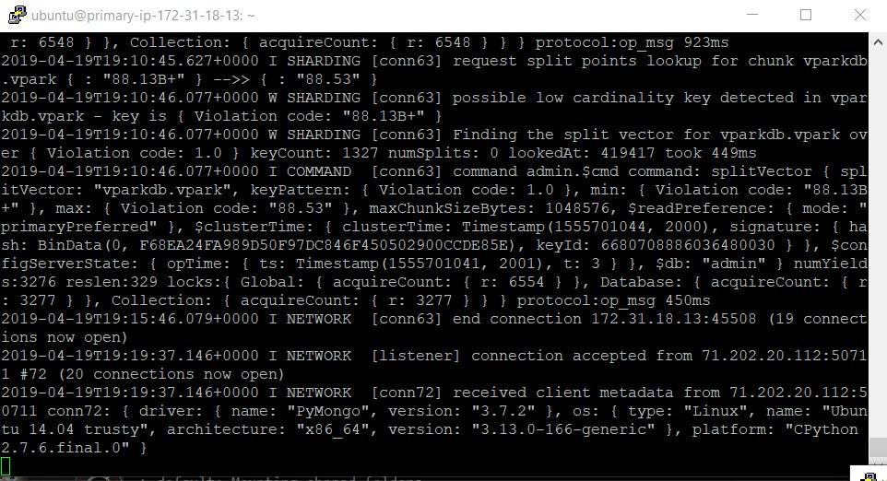

1. **NoSQL Driver and End-to-End Description From Application to Database**

Our high-level language of choice is Python, with PyMongo as the driver to connect and manipulate data in our MongoDB database. We used PyInquirer, a Python module for command line user interfaces, to format the interactive questions for our application.

Connecting to the database from Python through PyMongo is very simple, it first needs to be installed through the Python package manager then imported into the script file. It is then as simple as doing the following to connect to the database:

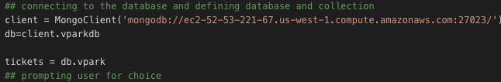

An example of querying the database using PyInquirer is as follows:

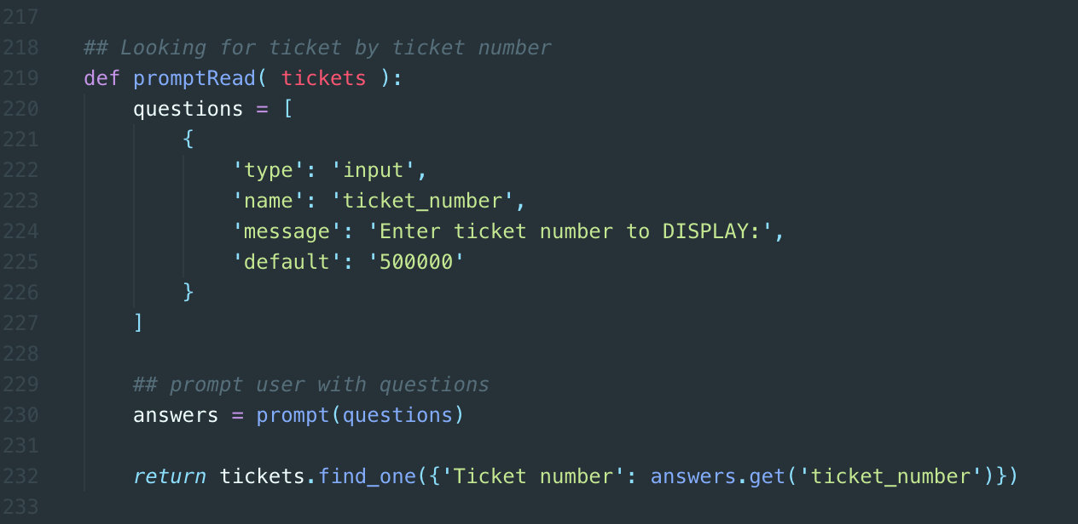

From there, the PyMongo will return collection that be easily used to retrieve data from. The results of these queries are shown in the functions in the following section.

1. **15 Functions**

This section details 15 use cases for our application that the user can perform. For each function we have written a corresponding MongoDB query, executed the function through out application, and provided a screenshot to show the results. We limited the outputted document results to 3 for the purpose of screenshotting. To perform these functions, the user can access the User Menu in the console by first running the application:

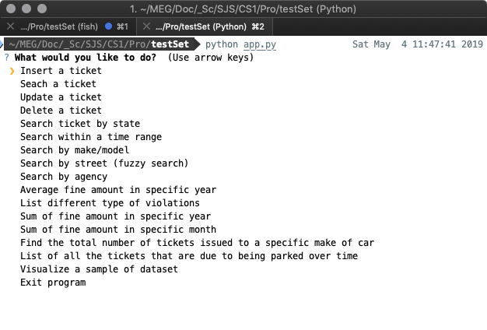

1. **Inserting a ticket**  
   → Insert ticket number 500000  
     
    ticket_data = {  
    "Ticket number": 500000,  
    "Issue Date": '2018-02-05T00:00:00',  
    "Issue time": 1216.0,  
    "RP State Plate": ‘CA’,  
    "Plate Expiry Date": 201807.0,  
    "Make": ‘NISS’,  
    "Body Style": ‘PA’,  
    "Color": ‘BK’,  
    "Location": ‘750 SPAULDING AVE S’,  
    "Route": 00144.0,  
    "Agency": 51.0,  
    "Violation code": ‘80.39BS’,  
    "Violation Description": ‘NO PARK/STREET CLEAN’,  
    "Fine amount": 73.0,  
    "Latitude": 6453238.3586370004,  
    "Longitude": 844996.969673  
    }  
   db.tickets.insertOne(ticket_data)  
     
   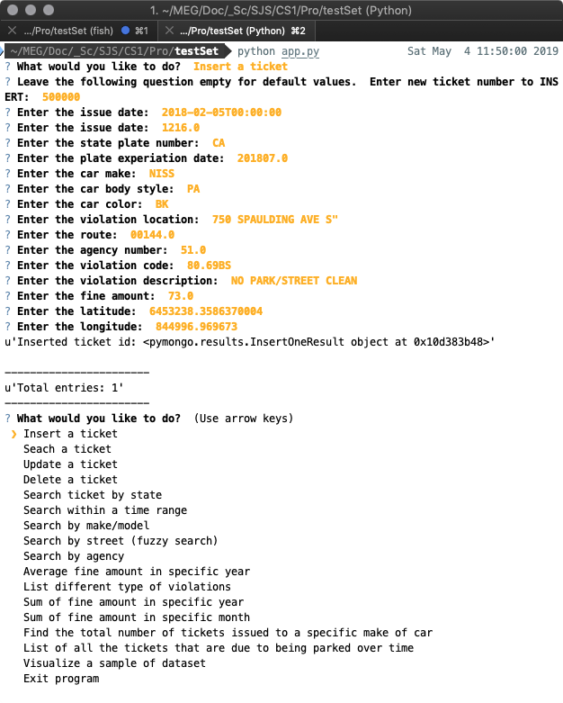
2. **Finding a ticket**  
   → Find ticket number 4325781762  
     
   db.tickets.find({"Ticket number": 4325781762})  
     
   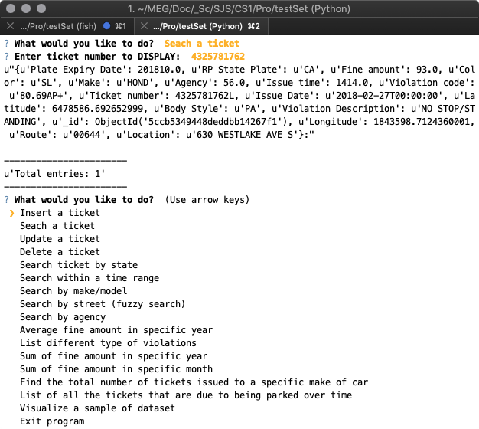
3. **Updating a ticket**  
   → Update ticket number 4325781762  
     
    updateFilter = {'Ticket number': 4325781762))}  
     
    ticket_data = {  
    "Ticket number": 4325781762,  
    "Issue Date": '2018-02-05T00:00:00',  
    "Issue time": 1216.0,  
    "RP State Plate": ‘CA’,  
    "Plate Expiry Date": 201807.0,  
    "Make": ‘NISS’,  
    "Body Style": ‘PA’,  
    "Color": ‘BK’,  
    "Location": ‘750 SPAULDING AVE S’,  
    "Route": 00144.0,  
    "Agency": 51.0,  
    "Violation code": ‘80.39BS’,  
    "Violation Description": ‘NO PARK/STREET CLEAN’,  
    "Fine amount": 73.0,  
    "Latitude": 6453238.3586370004,  
    "Longitude": 844996.969673  
    }  
     
    db.tickets.update_one(updateFilter, { $set : ticket_data})

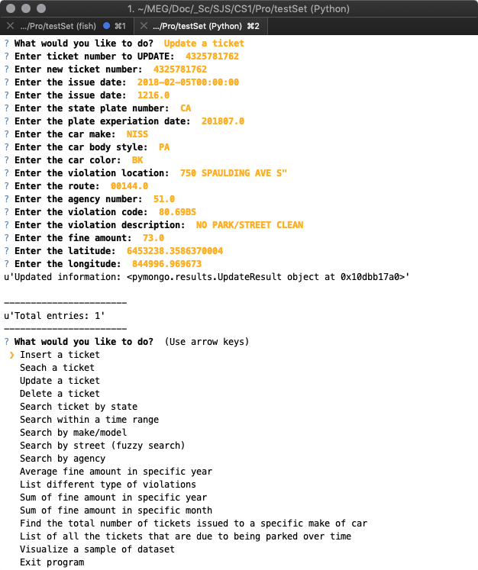

1. **Deleting a ticket**  
   → Delete ticket number 4325781762  
     
   db.tickets.deleteOne({“Ticket Number” : 4325781762})  
     
   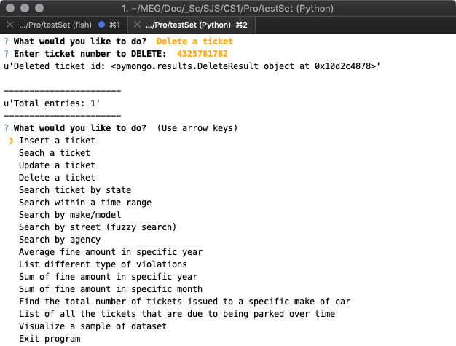
2. **List of all the tickets with a certain state plate**

→ Find all tickets where the car has a Nevada state plate

db.tickets.find({"RP State Plate": "NV"})

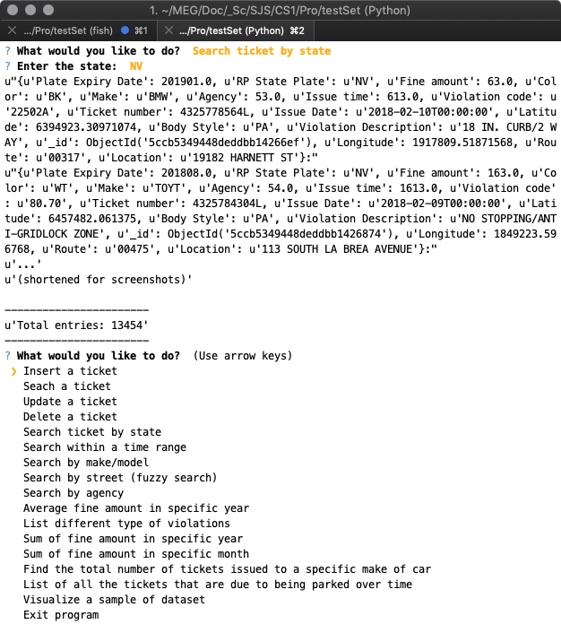

1. **List of all the tickets during a given time range**

→ Find all tickets that were issued between 2:00PM and 3:00PM (14:00 and 15:00 military time)

db.tickets.find({"Issue time": {$gte: 1400, $lte: 1500} })

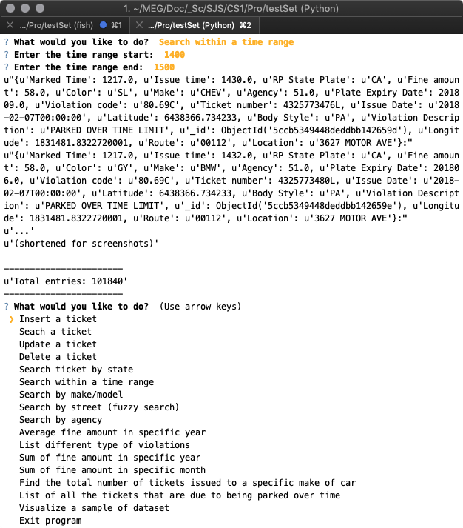

1. **List of all the tickets with a specific make of car**

→ Find all tickets issued to BMWs

db.tickets.find({"Make" : "BMW"})

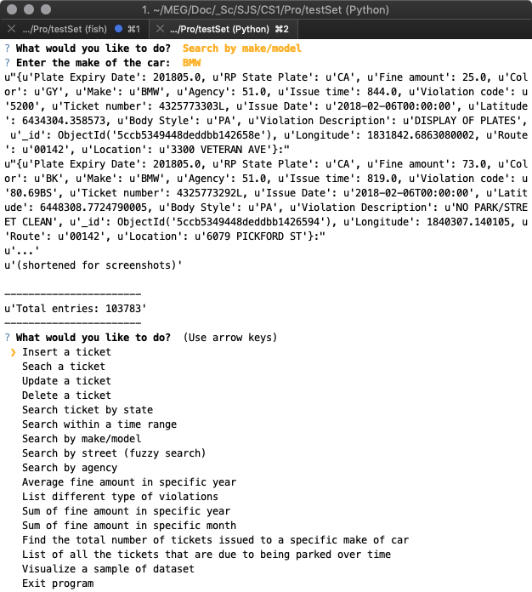

1. **List of all the tickets on a certain street**

→ Find all tickets issued on Cloverdale St.

(Note: fuzzy search means that it will search for the street name anywhere in the value of the street address in the document)

db.tickets.find({"Location": {$regex : ".*CLOVERDALE.*"} })

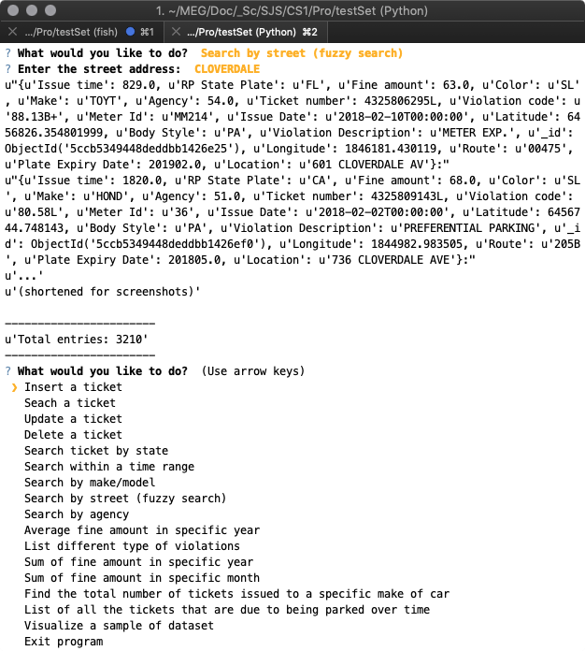

1. **List of all the tickets of a specific agency**

→ Find all tickets issued by the DOT Hollywood Agency, specified by code 54

(Note: The data set URL contains a table of Agency name to Agency code)

db.tickets.find({"Agency" : 54})

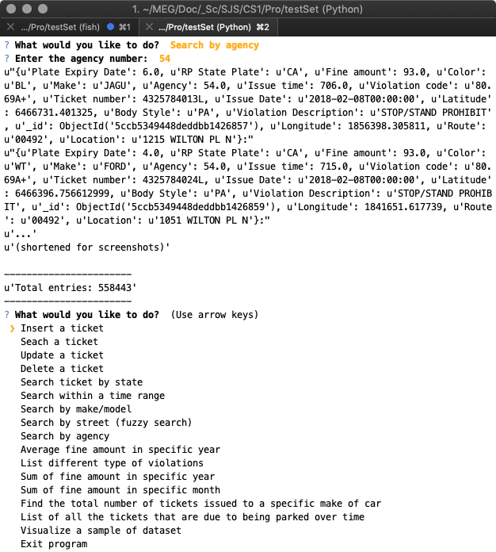

1. **Find the average fine amount in a certain year**

→ Find the average amount of fines from tickets issued in 2018

db.tickets.aggregate(

{ $match: { "Issue Date": {$regex : "2018-.*"} }},

{ $group: { _id: null, avgFine: {$avg: "$Fine amount" } } }

)

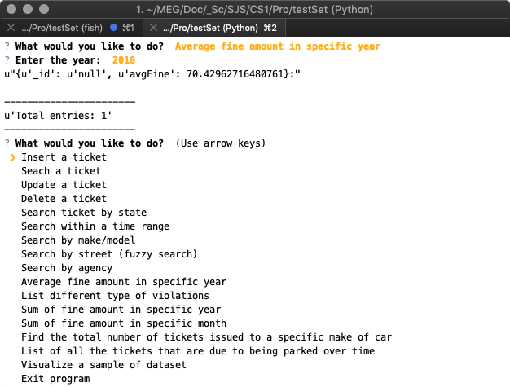

1. **List the different types of violations (violation code)**

db.tickets.distinct("Violation code")

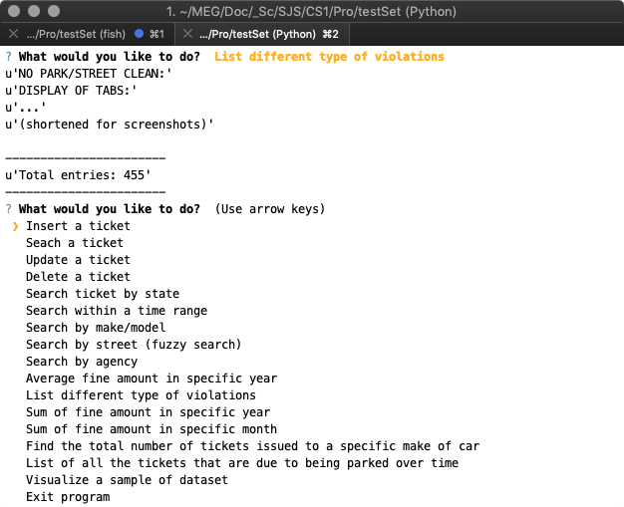

1. **Find the sum of the fines accumulated from a certain year**

→ Find the sum of the fines accumulated from the year 2019

db.tickets.aggregate(

{ $match: { "Issue Date": {$regex : "2019.*"} }},

{ $group: { _id: null, fineSum: {$sum: "$Fine amount" } } }

)

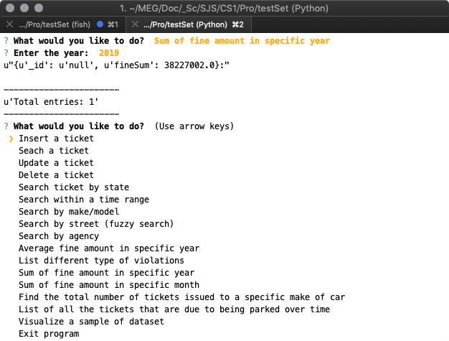

1. **Find the sum of fines issued from tickets from a certain month**

→ Find the sum of fines from tickets issued in May

db.tickets.aggregate(

{ $match: { "Issue Date": {$regex : ".*-05.*"} }},

{ $group: { _id: null, fineSum: {$sum: "$Fine amount" } } }

)

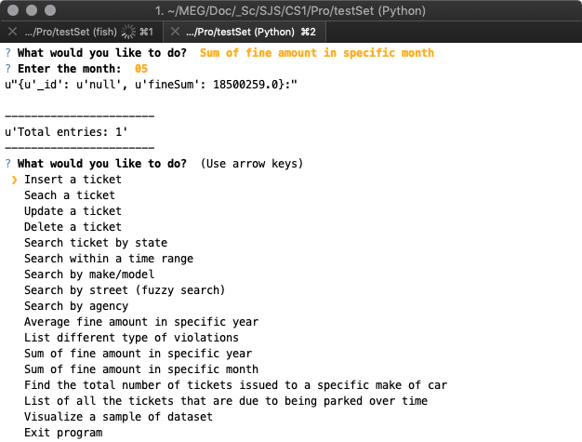

1. **Find the total number of tickets issued to a specific make of car**

→ Find the total number of tickets issued to Honda cars

db.tickets.aggregate(

{ $match: { "Make": "HOND" }},

{ $group: { _id: "Make", ticketCount: {$sum: 1 } } }

)

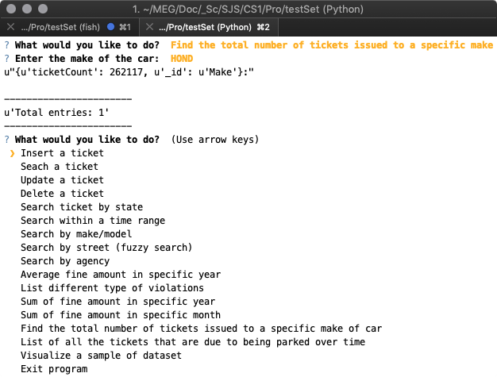

1. **List of all the tickets that are due to being parked over time.**

db.tickets.find({"Violation Description" : "PARKED OVER TIME LIMIT"})

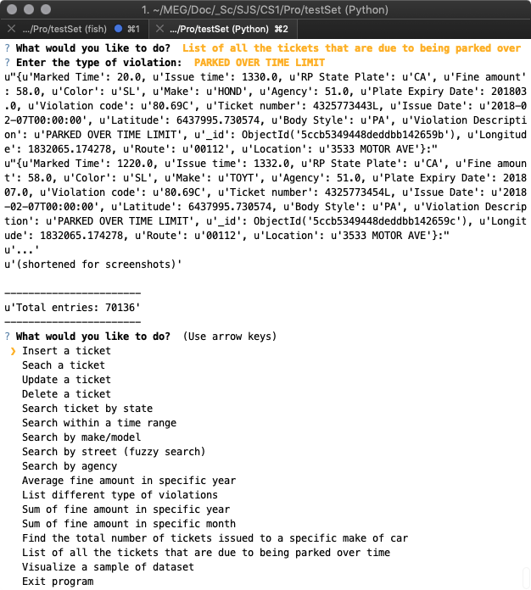

**Visualize a sample of dataset and exiting the application:**

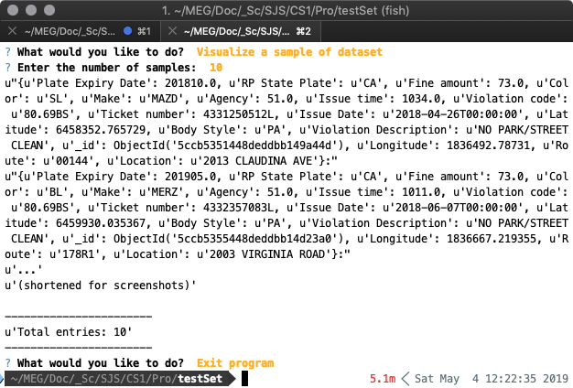

Aggregate query run from Mongo-shell on AWS to get sharding information:

